CSCE 438 HW 3.2 Design Document

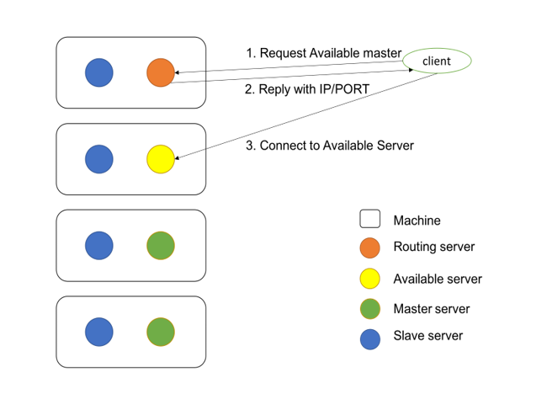

Routing server will always be started on first machine, with IP 10.0.2.15 at port 16666. All server will be listening on port 16666 at whatever IP address they may be on.

When each server starts up, they will connect to routing server and add their IP and port number to the routing server database.

When clients connect to routing server (default hostname and port argument on tsc startup), they will be redirected to an available server for processing their requests.

If a server crashes, then the routing server will detect this, and redirect users to the next available server.

If a server crashes, a slave server will restart the master server.